Business Data Management

Project Proposal



Case Study of Aren’s Fancy World
NAME: Bhavya Singh
EMAIL: 23f2005018@ds.study.iitm.ac.in
ROLL NO.: 23f2005018

Declaration

I am working on a project “Case Study of Aren’s Fancy World”, I extend my appreciation to Aren’s Fancy World for providing me the necessary resources that enable me to conduct my project.

Additionally, I affirm that all procedures employed for the purpose of data collection and analysis have been duly explained in this report. The outcomes and inferences derived from the data are an accurate depiction of the findings acquired through thorough analytical procedures.

I am dedicated to adhering to information of academic honesty and integrity, and I am receptive to any additional examination or validation of the data contained in this project report.

I understand that the execution of this project is intended for individual completion and is not to be undertaken collectively. I thus affirm that I am not engaged in any form of collaboration with other individuals, and that all the work undertaken has been solely conducted by me. In the event that plagiarism is detected in the report at any stage of this project’s completion, I am fully aware and prepared to accept disciplinary measures imposed by the relevant authority.

I agree that all the recommendations are business specific and limited to this project exclusively, and cannot be utilised for any other purpose with an IIT Madras tag. I understand that IIT Madras does not endorse this.

Signature of Candidate: 
Name: Bhavya Singh
Date: 03/11/2024
EXECUTIVE SUMMARY:
Aren’s Fancy World is a stationery and gift store located in Ghaziabad, Uttar Pradesh, India, established seven years ago. Known for its broad selection of daily stationery, gift items, toys, and books, the store recently relocated to a prime spot in Orbit Plaza, aiming to attract more students and families.
The store faces several operational challenges, including inventory spoilage due to unsold or outdated items, difficulties in retaining customers amid local and online competition, and managing inventory efficiently to meet demand without overstocking or understocking. These issues impact overall profitability, customer satisfaction, and daily operational efficiency.
To address these challenges, the project proposes a data-driven approach based on the analysis of inventory purchases, sales data, and profit margins. By examining the inventory levels, purchasing trends, and sales performance, data science methods can help identify underperforming items, optimize stock levels, and highlight areas for improvement in customer retention. Automated systems and insights from the collected data will support Aren’s Fancy World in achieving sustainable, efficient operations.

ORGANIZATIONAL BACKGROUND:
The business I am collaborating with is Aren’s Fancy World, a stationery and gift store that has been serving customers for seven years. Originally established in Panchsheel Square Mall in Crossing Republic, Ghaziabad, Uttar Pradesh, India, the store recently relocated to Orbit Plaza, also in Crossing Republic. The new location was chosen for its prime position, as it attracts frequent visits from students and families in the area, offering a significant advantage in terms of customer accessibility.
Aren’s Fancy World offers a wide selection of essential stationery products for everyday use, along with a diverse array of gift items. Its inventory also includes toys and storybooks specifically designed for toddlers, ensuring there is something for everyone, from students to young children. The business strives to meet the varied needs of its customers with a thoughtful range of products, making it a one-stop destination for both practical supplies and gift options.

PROBLEM STATEMENT:
Aren’s Fancy World faces several key challenges that impact its ability to remain competitive and grow its market share.
- Inventory Spoilage is an issue due to unsold or aging stock, especially in items with shorter shelf lives or seasonal demand. This leads to unnecessary costs and limits available space for high-demand products.
- Customer Retention and Competition pose ongoing challenges as the store competes with other nearby shops that offer similar products. With customers often prioritizing convenience and product availability, stock shortages can lead them to purchase from competitors, impacting loyalty and sales.
- Inventory Management is a persistent issue, as it’s difficult to maintain the right balance of products to meet demand consistently. Inefficient inventory practices result in either overstocking or understocking, affecting both customer satisfaction and operational costs.

BACKGROUND OF PROBLEM:
Aren’s Fancy World, a stationery and gift store, is facing challenges in inventory management, customer retention, and maintaining a competitive edge. Located in a prime retail area with numerous similar stores, the business is struggling to keep pace with the demands of a competitive market where customers prioritize availability and variety. The root of these issues lies in the store's approach to inventory control and its response to fluctuating demand.
The major cause of the problem is the difficulty in maintaining optimal stock levels to meet customer demand, resulting in frequent shortages or excesses. When popular items are out of stock, customers tend to seek alternatives from nearby stores, which erodes customer loyalty.

Several internal factors contribute to this issue. Inefficient tracking systems, limited analysis of sales trends, and suboptimal inventory planning lead to inventory spoilage and unmet demand. Additionally, inconsistent restocking schedules and limited forecasting tools exacerbate the issue, causing stock mismanagement.

External factors also play a significant role. Competing stores in the area provide alternatives for customers, increasing the risk of lost sales when stock levels at Aren’s Fancy World are low. The changing preferences of customers and seasonal fluctuations further complicate inventory planning. Together, these factors make it challenging for the store to meet customer expectations, retain loyalty, and stay competitive in a high-demand location.

PROBLEM SOLVING APPROACH:
To address the challenges faced by Aren’s Fancy World, a multifaceted problem-solving approach will be implemented, leveraging data analytics and technology to enhance inventory management, customer retention, and competitive positioning. This approach will be structured around three core strategies: data collection and analysis, technology integration, and continuous improvement.

1. Data Collection and Analysis:
The first step involves comprehensive data collection from various sources, including sales transactions and inventory levels. By analysing the items purchased, their prices, and the corresponding sales data, the store can identify purchasing trends and patterns. This analysis will enable the business to categorize products based on demand, seasonality, and customer preferences.
Utilizing techniques such as predictive analytics and inventory forecasting will help the store anticipate future demand more accurately. For instance, analysing historical sales data can reveal peak shopping periods, allowing for better preparation in stock levels. Additionally, identifying underperforming items through sales data will facilitate timely decisions on discounts or promotions to clear out excess inventory, thus reducing spoilage.

2. Technology Integration:
Implementing technology solutions is crucial for enhancing operational efficiency. An integrated inventory management system can automate tracking stock levels in real time, providing insights into when to reorder and how much to order. This system can also incorporate alerts for low stock levels and expiration dates for perishable items, minimizing the risk of inventory spoilage.
Moreover, integrating an online sales platform can expand customer reach and improve accessibility. This platform should be user-friendly and provide features like real-time inventory updates, allowing customers to check product availability before visiting the store. The addition of an e-commerce option will not only facilitate sales during non-business hours but also cater to customers who prefer online shopping.

3. Continuous Improvement:
Finally, fostering a culture of continuous improvement will ensure that the solutions implemented remain effective and relevant over time. Regularly reviewing sales and inventory data will allow the team to adjust strategies as needed based on evolving market conditions and customer preferences. Soliciting customer feedback through surveys or social media can provide valuable insights into satisfaction levels and areas for enhancement.

Training employees on the new systems and processes will be vital to ensure successful implementation. By empowering staff with the knowledge and tools to manage inventory effectively and provide excellent customer service, Aren’s Fancy World can build a loyal customer base.
By integrating data-driven decision-making with advanced technology and a commitment to continuous improvement, Aren’s Fancy World will be well-positioned to overcome its current challenges and enhance its operational efficiency, ultimately leading to increased customer satisfaction and a stronger market presence.

EXPECTED TIMELINE:
- Work Breakdown Structure:
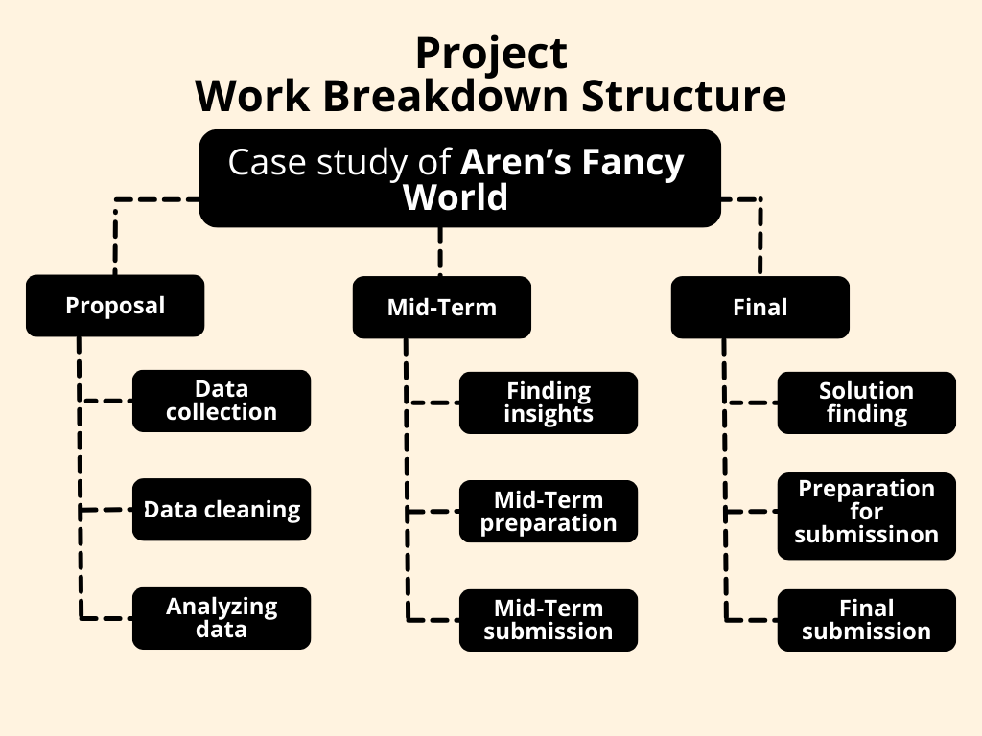

- Gantt Chart:
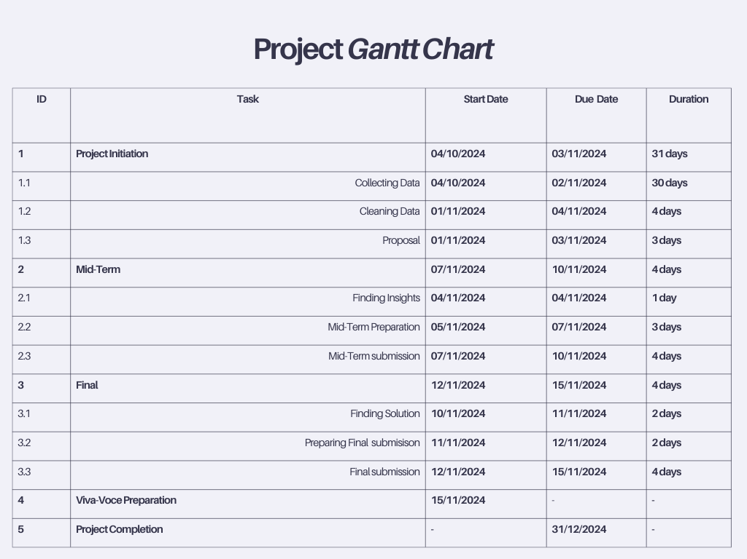

EXPECTED OUTCOME:
By implementing the proposed problem-solving approach, Aren’s Fancy World anticipates several positive outcomes that address the identified challenges of inventory spoilage, customer retention, and competitive positioning.
Firstly, the integration of a robust inventory management system will lead to better stock control, reducing the incidence of stock shortages and minimizing spoilage. This will ensure that popular items are consistently available, thus enhancing customer satisfaction and loyalty.
Secondly, leveraging data analytics to understand purchasing patterns will enable the store to optimize its product offerings, tailoring inventory to meet customer demand more effectively. This targeted approach will likely result in improved sales performance and a reduction in excess inventory.
Additionally, the establishment of an online sales platform will expand market reach, allowing customers to access products conveniently, even during non-business hours. This is expected to attract new customers and retain existing ones who prefer the convenience of online shopping.

Ultimately, these strategies will contribute to increased operational efficiency, greater profitability, and a stronger competitive position within the market, positioning Aren’s Fancy World for long-term success.

